**EXPERIMENT-1**

**Aim:** Write SQL queries to create for various databases using DDL commands (i.e. CREATE, ALTER, DROP, TRUNCATE).

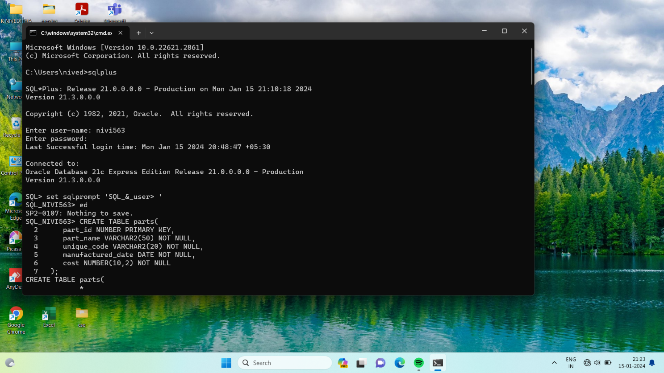

**CREATE TABLE:**

Creates a table with specified constraints.

**Syntax:**

CREATE TABLE tablename (

Column2 data_type[constraint],

PRIMARY KEY (column1[, colunmn2]),

FOREIGN KEY (column1[, column2]) REFERENCES tablename] [, CONSTRAINT constraint]);

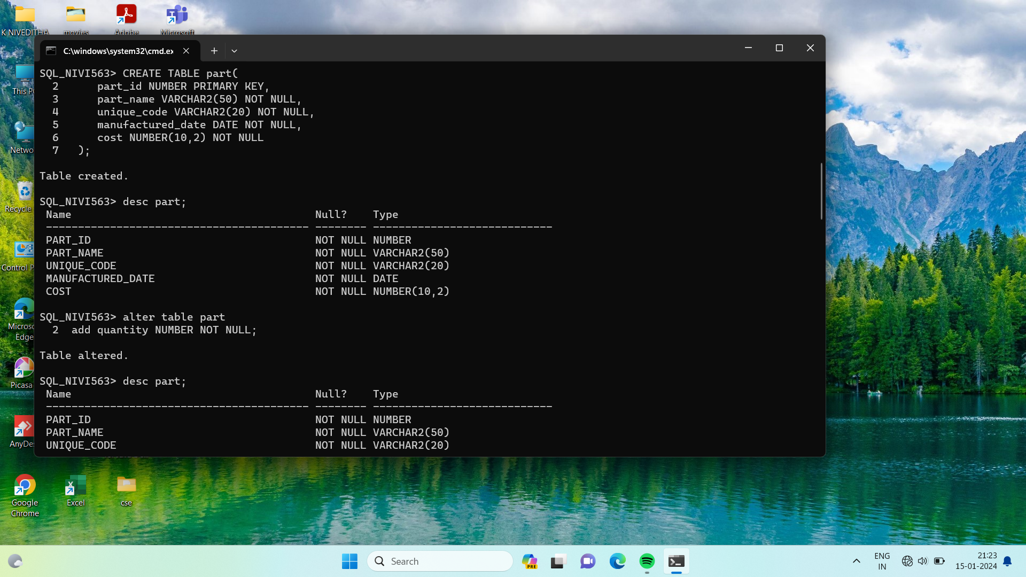



**ALTER TABLE:**

Used to add or modify table details like column names and data types, column constraints.



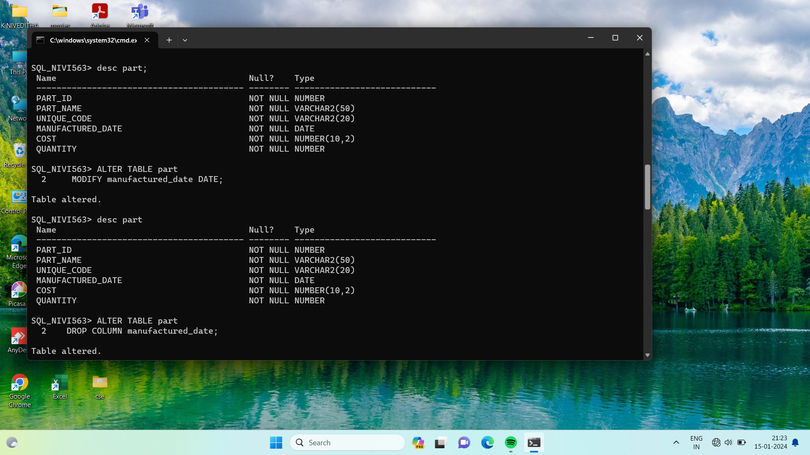

**DROP TABLE:**

Deletes the specified table.

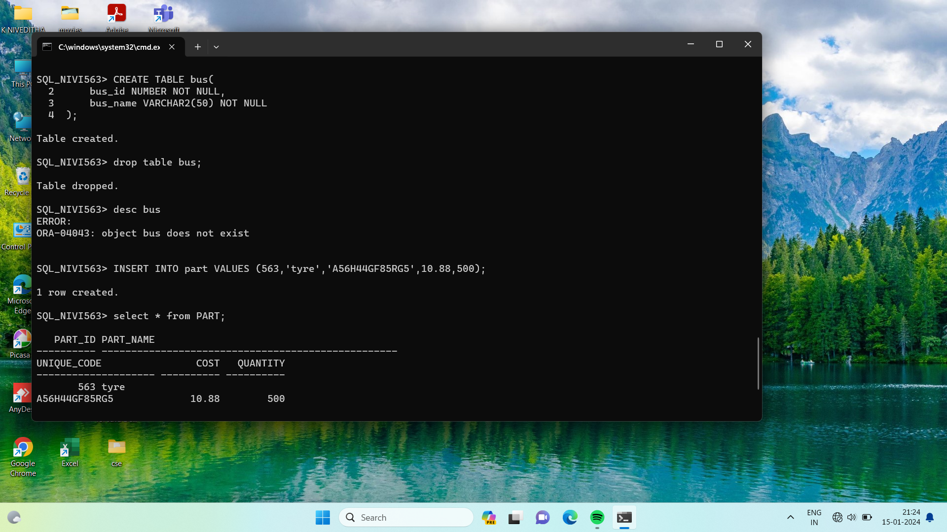

**Syntax:**

DROP TABLE table_name;

**RENAME TABLE:**

To rename table_name, column_name.

**Syntax:**

RENAME new_table_name TO old_table_name;

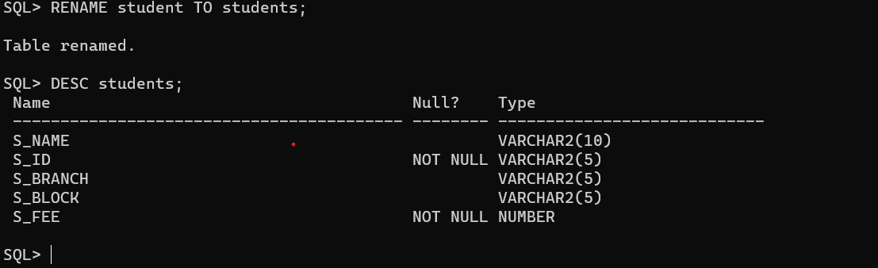

**TRUNCATE TABLE:**

To remove all rows in a specified table.

**Syntax:**

TRUNCATE TABLE table_name;

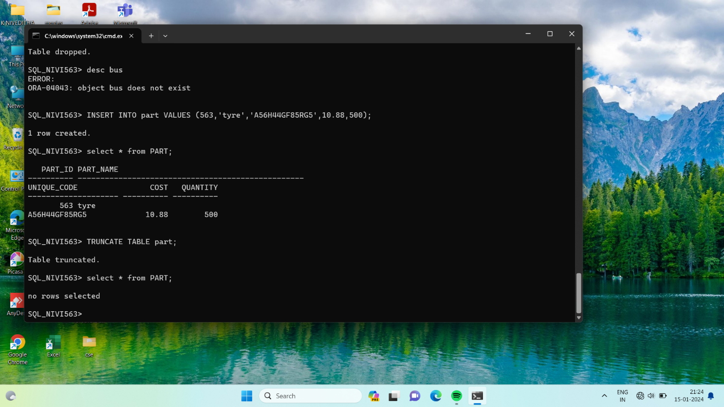

**Conclusion:**

In this lab, we have practiced CREATE, ALTER, DROP, and TRUNCATE commands for the user created table.